**AWS Task-2**

**Task Description:**

Set up a VPC with an Internet gateway, create a public subnet with 256 IP addresses, a private subnet with 256 IP addresses, make a route table connecting the Internet gateway and the subnets, and launch a Linux EC2 instance by using the above VPC and public subnet.

**Created** **VPC🡺**

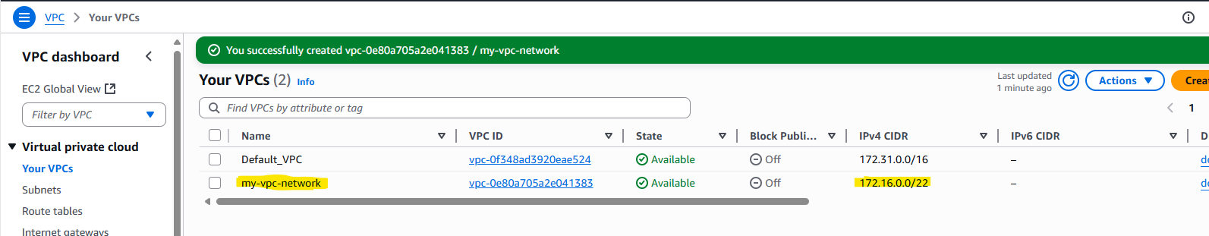

**Created Private and Public Subnets** 🡺

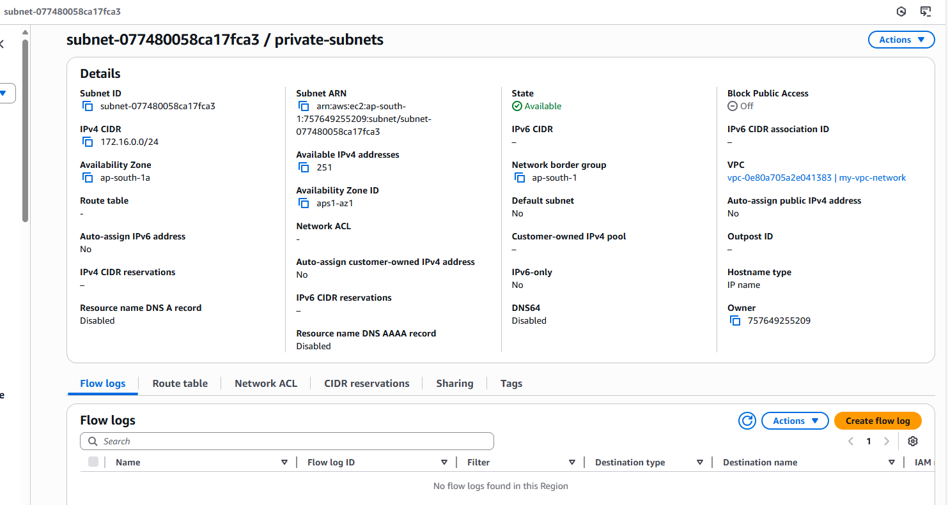

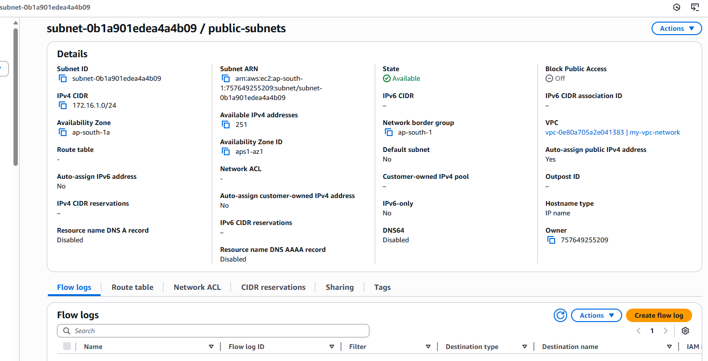

**Created internet Gateway and Attached to the VPC🡺**

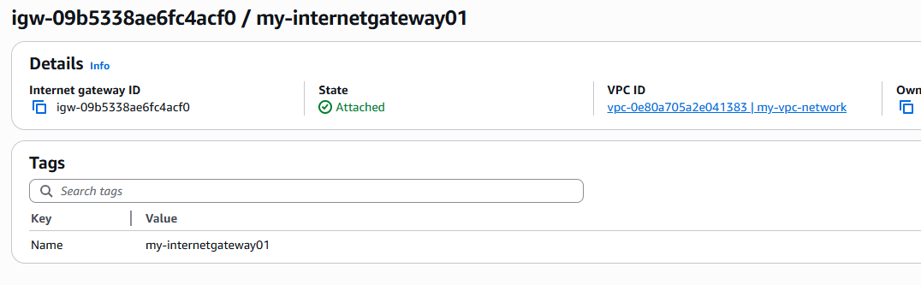  
  
**Created RouteTable for Public and Private Subnets Routes🡺**

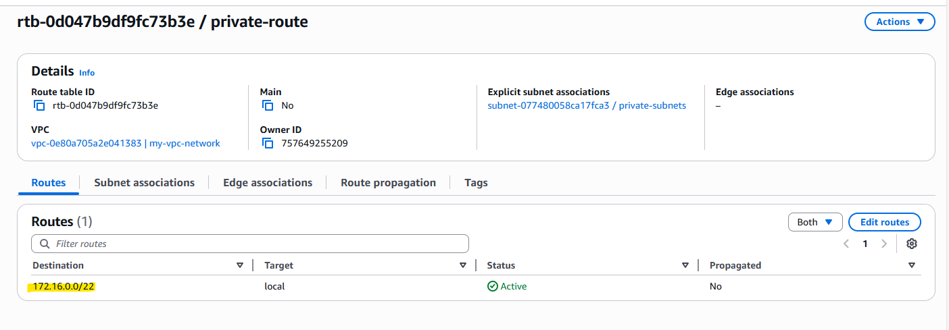

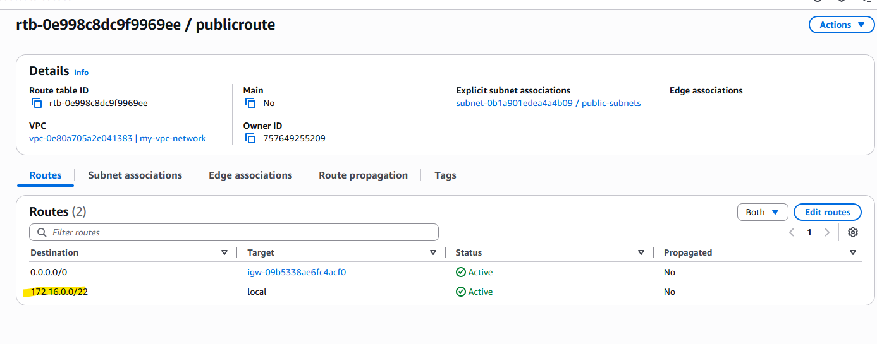  
  
**Launching Ec2 instance** 🡺

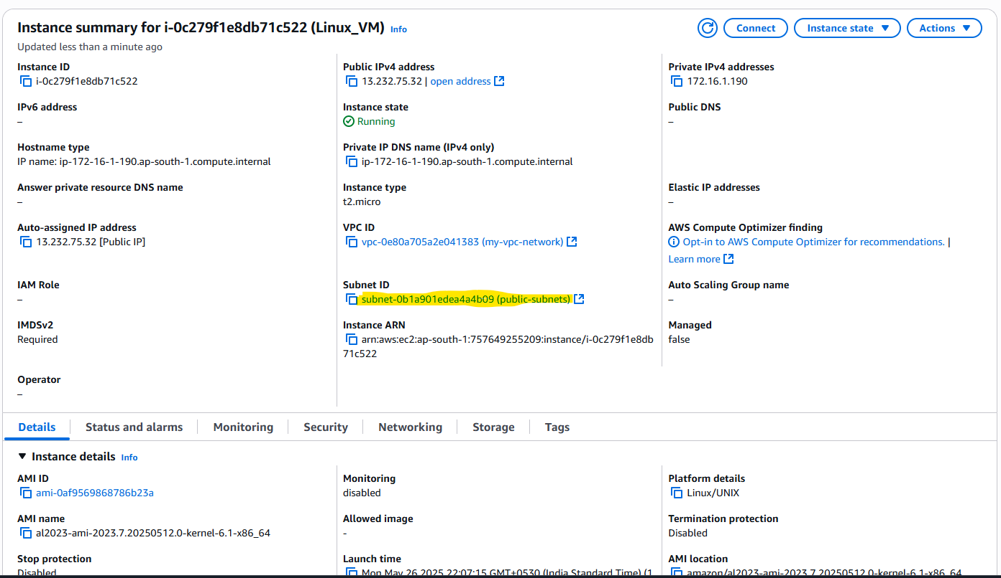

**Connection and Testing Ec2 instance** 🡺

